CST2355 – Database Systems Lab Assignment 2

Student Name: Nouraldin Hassan

Student ID: 041054019

Student email: hass0443@algonquinlive.com

# Hand-in:

1. The lab assignment will be graded out of a maximum 4 points.
2. This template should be used to submit your lab assignment.
3. Make sure you have enough screenshots to completely document that you have completed all the steps.

# Activities (Steps):

1. Continue using the copy of the Northwind online database template that you used for Lab Assignment 1 (if necessary create a new one – with the Departments and Roles tables too).
2. Move the form that you created for Lab 1 into a new subgroup called “Lab 1”. Then, move the sub-form that you created for the employee data into the same Lab 1 group.
3. Use the Query Tool to create a new Query that creates a joined view of all the employee, department, role, and privilege information by joining the employee table with the associated tables (see below). Take careful note of the properties of the joins between the tables: e.g., the arrow on the link between Employees and Employee Privileges. By specifying the join properties, the wizard will use the appropriate LEFT JOIN, RIGHT JOIN, or INNER JOIN when creating the query.

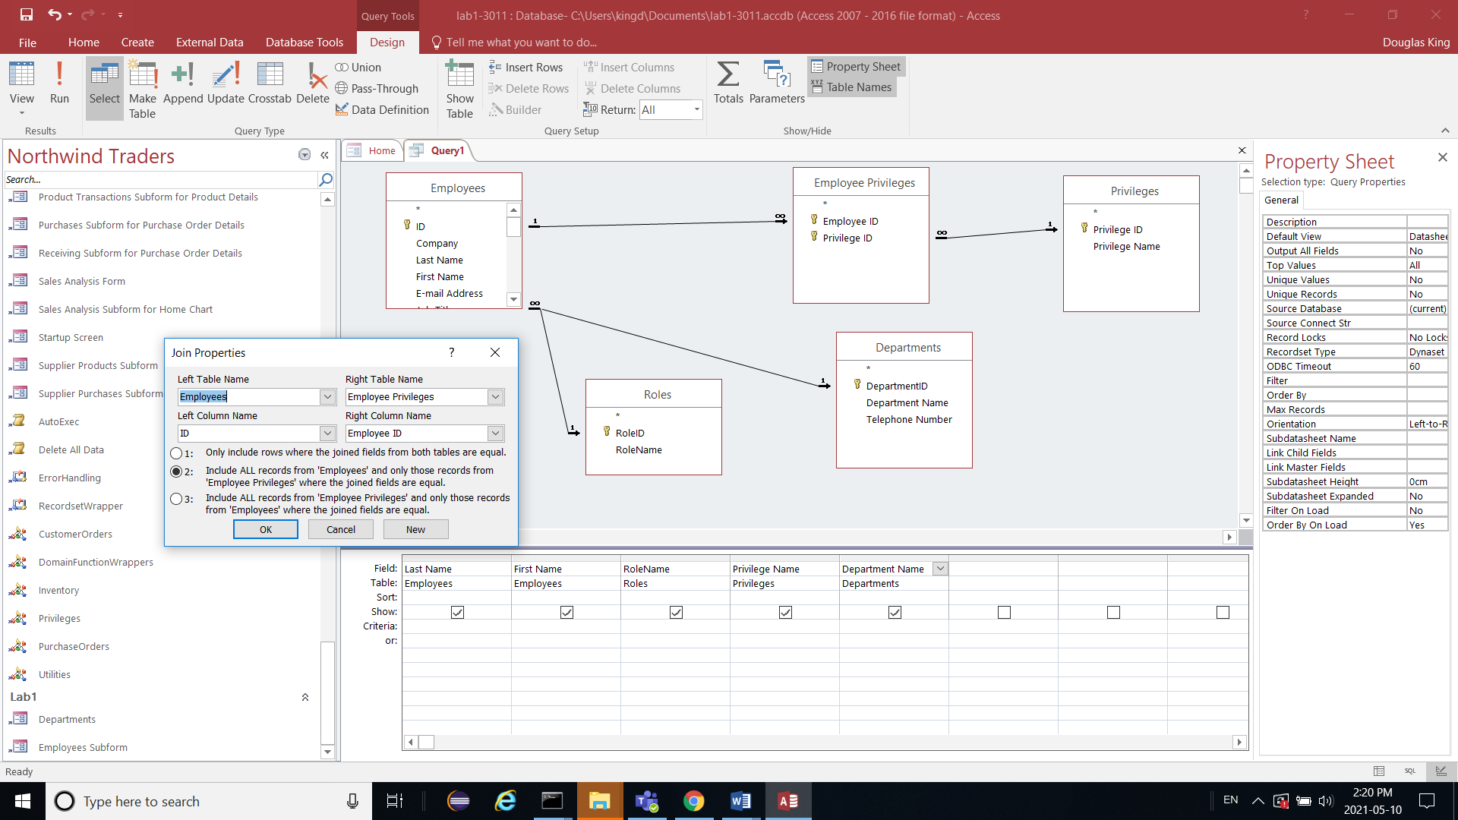

* 1. Once the query is saved, use the SQL view to show the underlying SQL. (Create a screen shot of the SQL with the SQL visible….)
  2. Try executing the query by moving to the Datasheet view. What happens? If you have errors adjust the relationships until the query runs. Show the result.
  3. Save the Query as “Query1Unsorted” and move it to a new group called Lab2.
  4. Edit the Query to select only employees with last names starting with the same first letter as your last name (for “King” that would be “K”). Include the following fields (“Lastname” (sorted ascending, “Firstname” (ascending), Department (ascending), Role (ascending), and Privilege (ascending). Add another employee to the employee table that has the same first letter in their last name. Save the new Query as Query1Sorted and move it the Lab2 group. Run the query and show the datasheet view below.
  5. Save and move the Query to the Lab2 Group with the name “Query1Sorted”.

1. Create a report that groups all of the employees by their last names; with a heading of for each Alphabet letter; e.g., A followed by, B followed by, C, etc. Each grouping should contain the person’s last name, firstname, and role.
   1. You should start by looking at the alphabetical employee address book. You can use it as a model to either edit the address book to become the roles book, or you can create a new one using a wizard.
   2. You may need to create some new employees to get a nice screenshot
   3. Show the resulting report below. Save it in the lab2 group as “employee role book”.
2. Create an MS-Excel worksheet containing the hobbies for some employees.
   1. Start with an empty MS-Excel worksheet.
   2. In the first row, put the column headings: “RowNumber”, Lastname”, “Firstname”, and “Hobby”.
   3. Look at the employee data in the Northwind Database and enter some rows in the MS-Excel worksheet to show a hobby for an individual employee.
   4. Make sure you put at least two rows for your own name. (Note: this means that there will be two rows with the same Lastname and Firstname; the RowNumber will become the key when we move the data to Access). MAKE SURE THE NAMES MATCH THOSE IN THE Access DATABASE!
   5. Show a screenshot of your populated MS-Excel table below.
3. Using the “External Data” menu, import the data from the MS-Excel worksheet (use RowNumber as the primary key).
   1. When prompted near the end of the pop-ups, you should save the steps as “Import-employee-hobby-data” to allow for a quick re-import.
   2. Save the imported table as “EmployeeHobbyData”. Provide a screenshot of the table contents.
4. Update the MS-Excel worksheet and re-import it with a new name using the following steps:
   1. Update the MS-Excel worksheet containing the employee hobby data. Show a screenshot of the updated table.
   2. Re-import the worksheet into the “EmployeeHobbyData2” table (note the new name!) Show a screenshot of the updated data.
5. Using the “External Data” menu, **link** to the data in the MS-Excel worksheet (use RowNumber as the primary key).
   1. Save the imported table as “EmployeeHobbyDataLinked”.
   2. After the linking is complete, open the linked table from inside Access and provide a screenshot. You should see the updated data.
   3. Open the “EmployeeHobbyData” table that you had imported and provide a screenshot. You should see the original data.
6. Using the following steps, create a new table that contains each of the unique hobbies; with a new field “HobbyID” (which is an AutoNumber key), and “HobbyName”. You will need to design a query that selects the appropriate list, and then use it as a make table query.
   1. Create a new “Select” query that produces the set of unique hobbies by using the DISTINCT keyword. Save the query as MakeHobbies1.
   2. Modify MakeHobbie1 to be a Make Table Query, and then save it. Run the query carefully and store the resulting table as “Hobbies”.
   3. Open the new Hobbies table in DataSheet View and take a screenshot.
   4. Open the Hobbies table in Design View, and add “HobbyID as an Auto Number primary key. Save the table. Take a screenshot of the finished Hobbies table with the populated keys.
7. Following a similar process as for Step 9 above, use the Make Table feature to create a new table to hold the many-to-many relationship with the fields “EmployeeID”, and “HobbyID” that is populated with the data from the joined Employees, Hobbies, and EmployeeHobbyData tables.
8. Create a new report based on the employee role report that shows the hobbies instead of roles. Provide a screenshot.
9. Tidy up your work into groups for lab1 and lab2. Take a screenshot showing the resulting groupings.
10. OPTIONAL BONUS (to ensure 100%): Create a modified version of the employee hobbies report that uses the data from the linked EmployeeHobbyDataLinked table rather than the EmployeeHobbyData table. Provide a screenshot. It should show the current data values at the time the report is generated (the new values!)
11. Once you have embedded all of your screenshots, submit the file in Brightspace and you’re done!